SCHOOL OF COMPUTER SCIENCE AND ARTIFICIAL INTELLIGENCE |  |  |  |  | DEPARTMENT OF COMPUTER SCIENCE ENGINEERING
Program Name: M. Tech/MCA/MSC |  |  |  | Assignment Type: Lab |  |  | AcademicYear:2025-2026
Course Coordinator Name |  |  |  | Venkataramana Veeramsetty
Course Code |  |  |  | Course Title |  | AI Assisted Problem Solving Using Python
Year/Sem |  |  | II/I | Regulation |  | R24
Date and Day  of Assignment |  |  | Week5- Tuesday | Time(s)
Duration |  |  | 2 Hours | Applicable to  Batches
AssignmentNumber:12.3(Present assignment number) /24(Total number of assignments)
 | Q. No. | Question |  |  |  |  |  | Expected Time  to complete
 | 1 | Lab 12 – Algorithms with AI Assistance: Sorting, searching, and optimizing algorithms  Lab Objectives  - To implement classical algorithms (sorting, searching) with the help of AI tools.  - To analyze AI suggestions for efficiency and correctness.  - To explore AI-assisted optimizations of existing algorithms.  - To compare naive vs. optimized approaches generated by AI.  Learning Outcomes  After completing this lab, students will be able to:  • Implement sorting and searching algorithms using AI suggestions.  • Compare AI-generated algorithm variants in terms of readability and efficiency.  • Use AI to optimize brute-force algorithms into more efficient ones.  • Analyze algorithm complexity (time and space) with AI explanations.  • Critically reflect on correctness, clarity, and maintainability of AI-generated algorithms.  Task Description #1 – Linear Search implementation  Task: Write python code for linear_search () function to search a value in a list and extract its index.  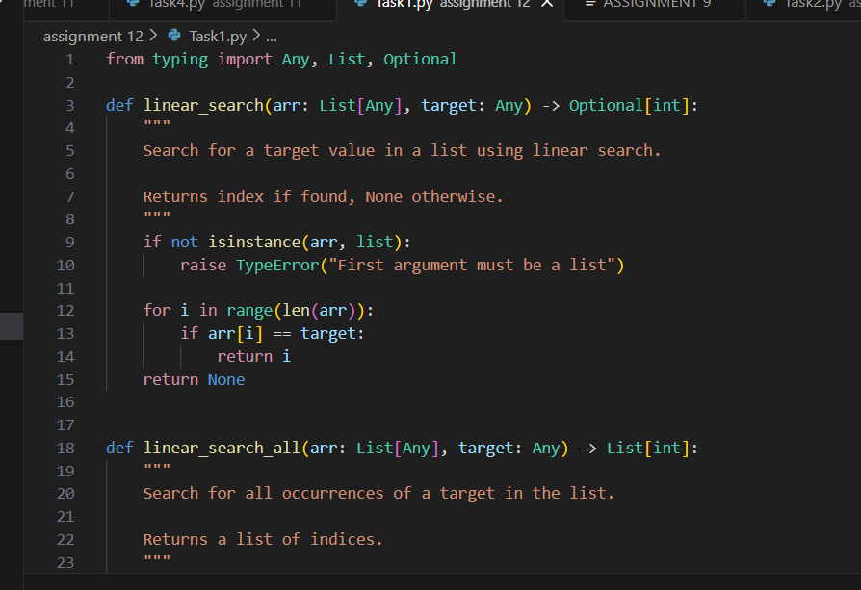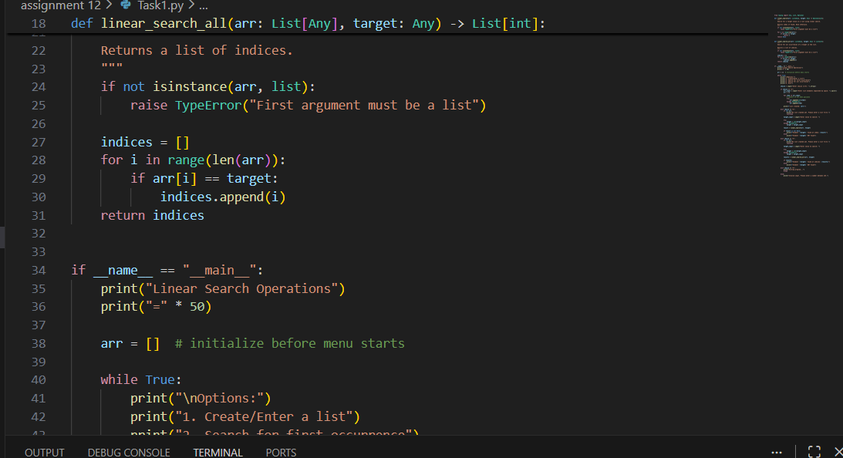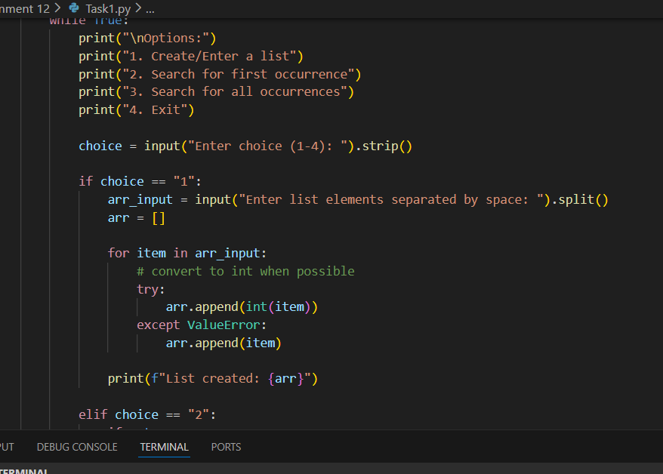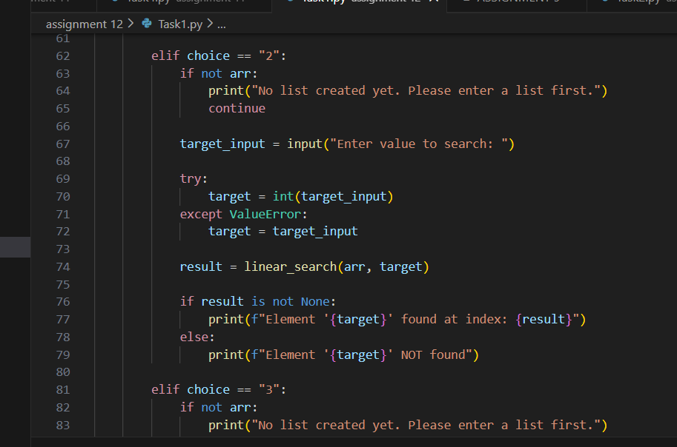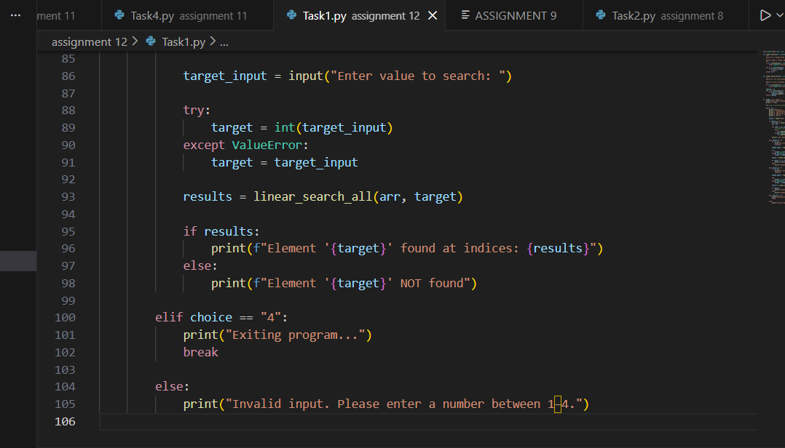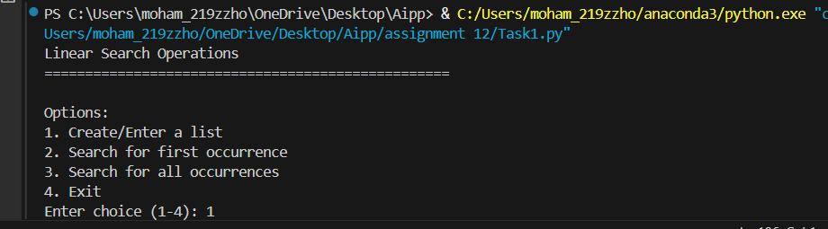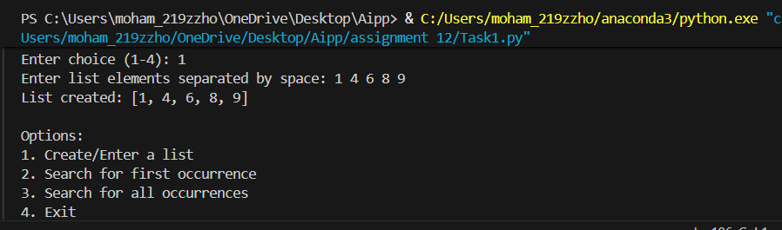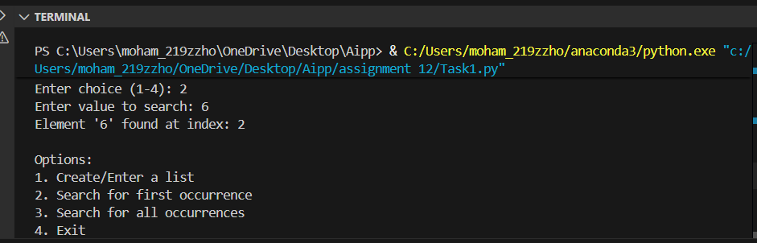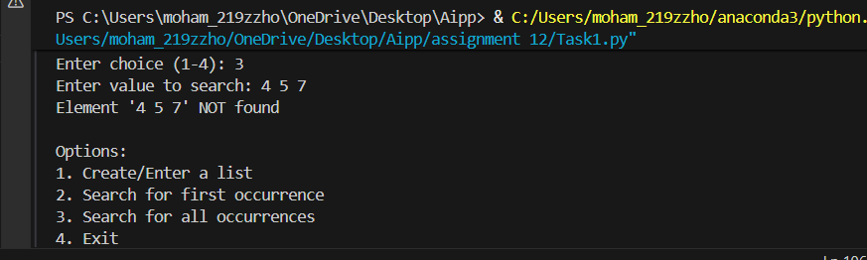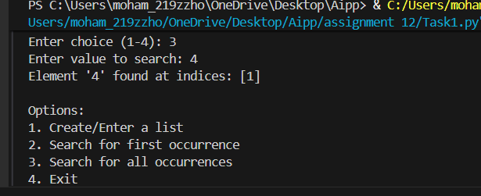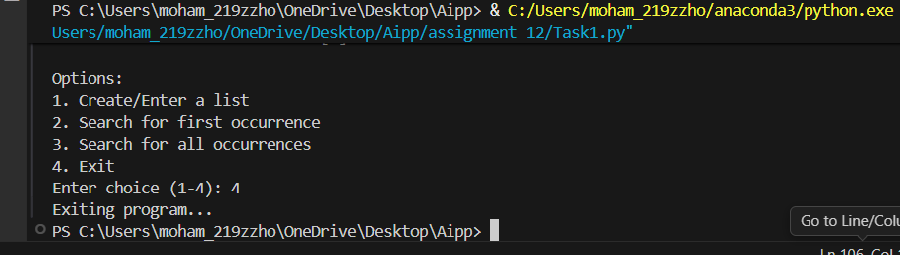  Task Description #2 – Sorting Algorithms  Task: Ask AI to implement Bubble Sort and check sorted output  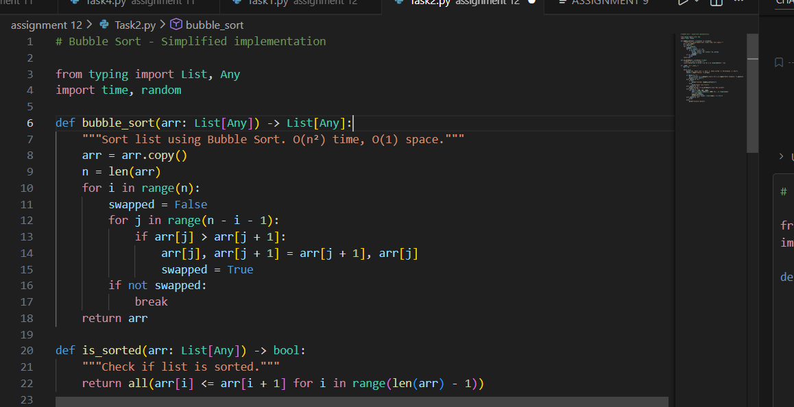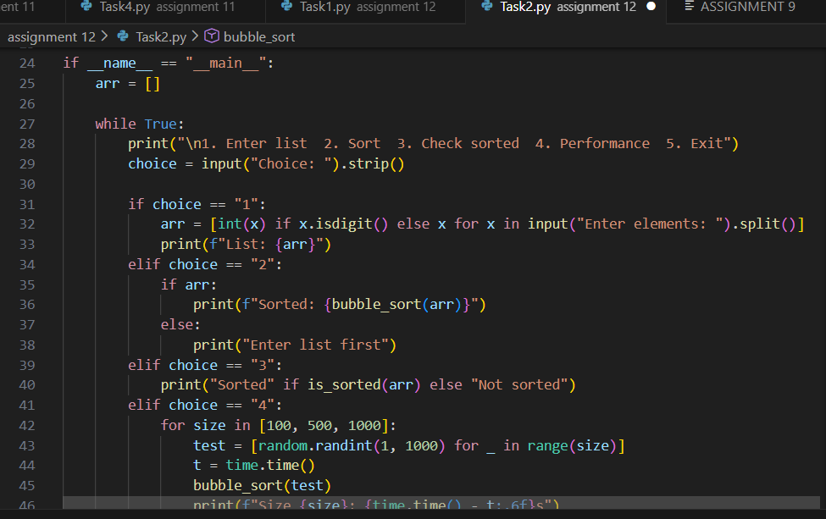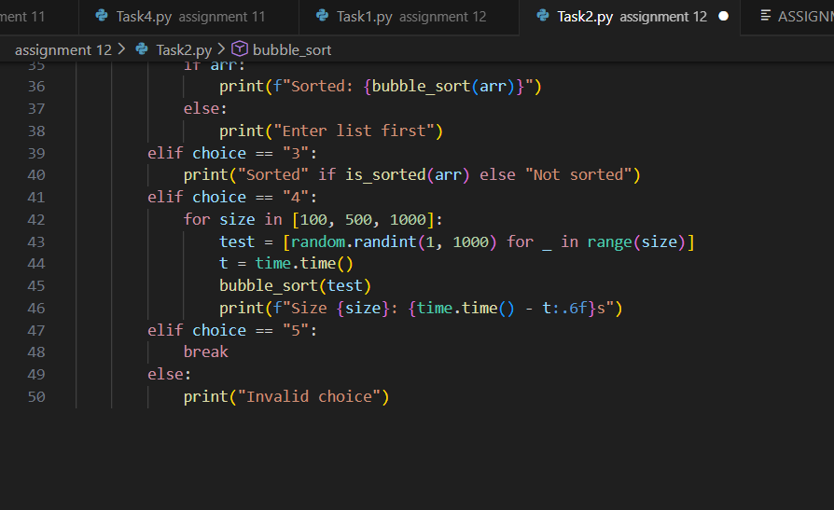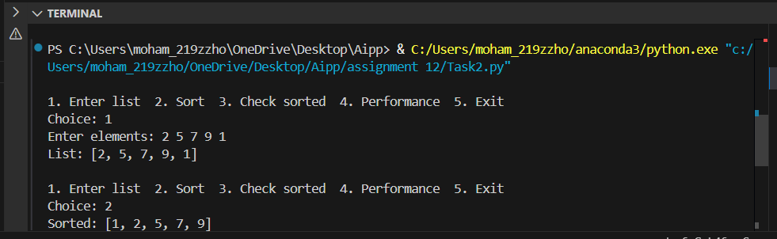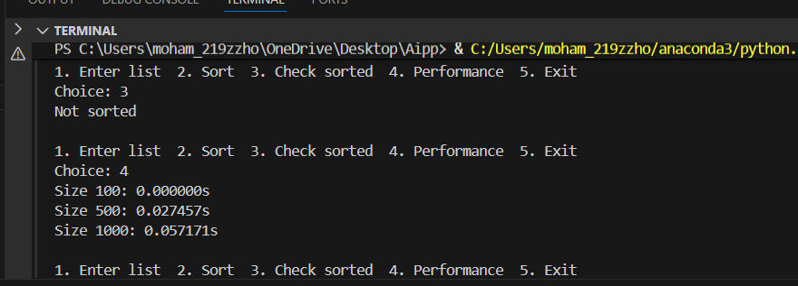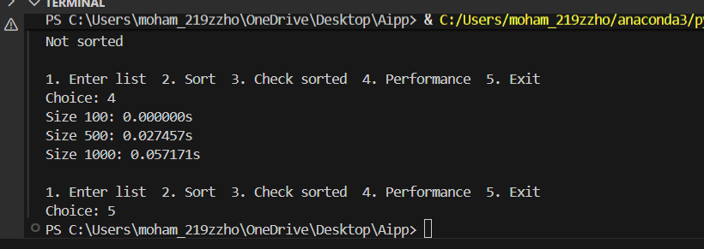  Task Description #3 – Optimization  Task: Write python code to solve below case study using linear optimization    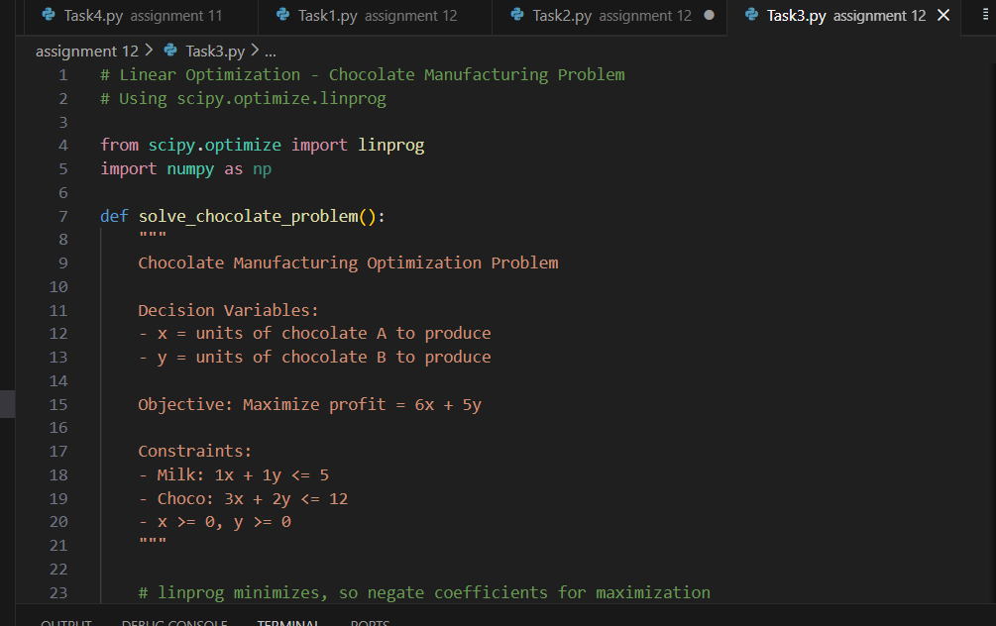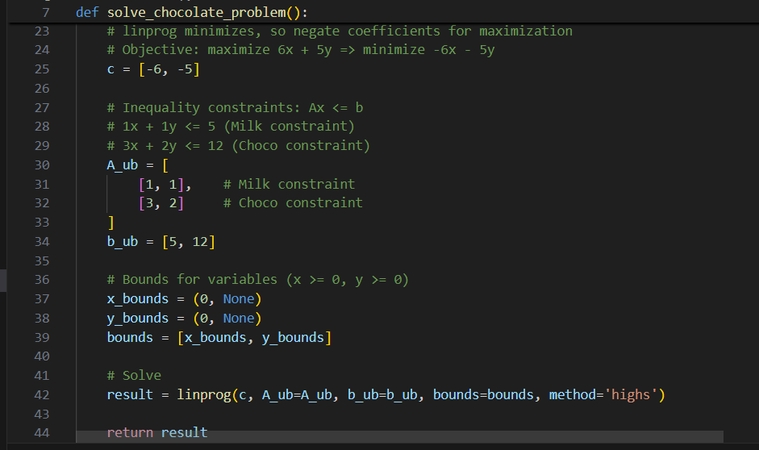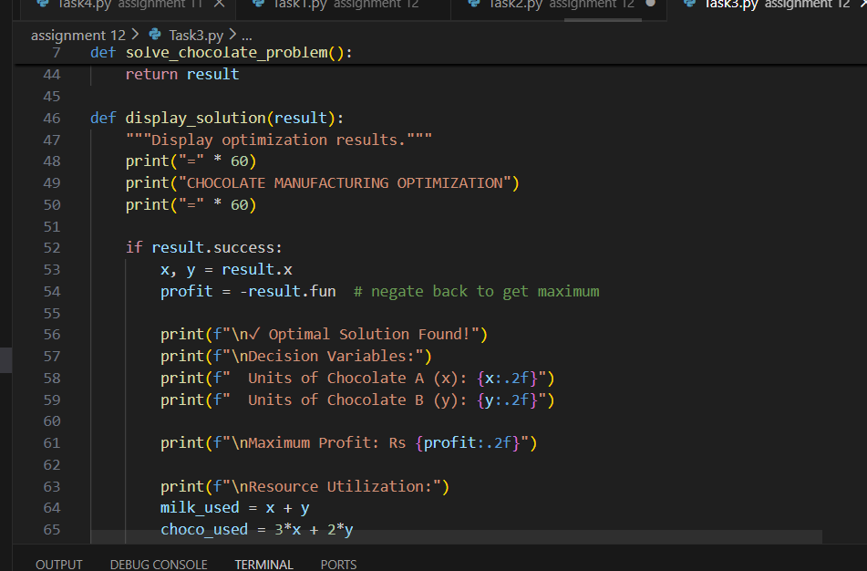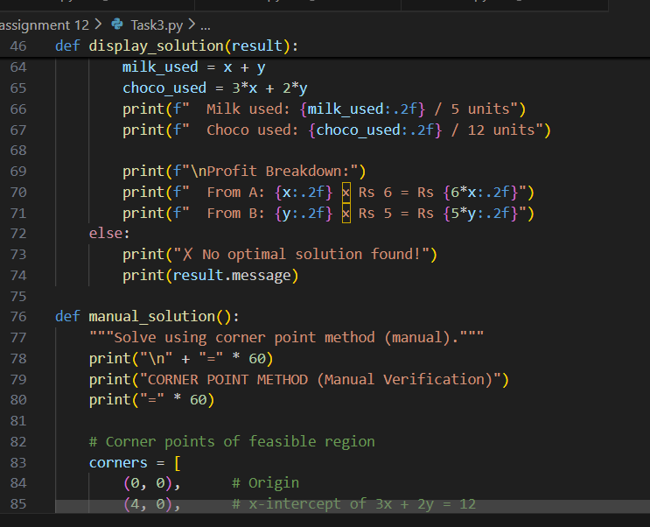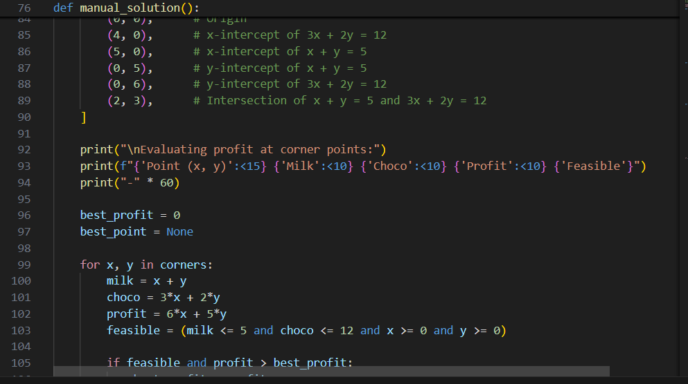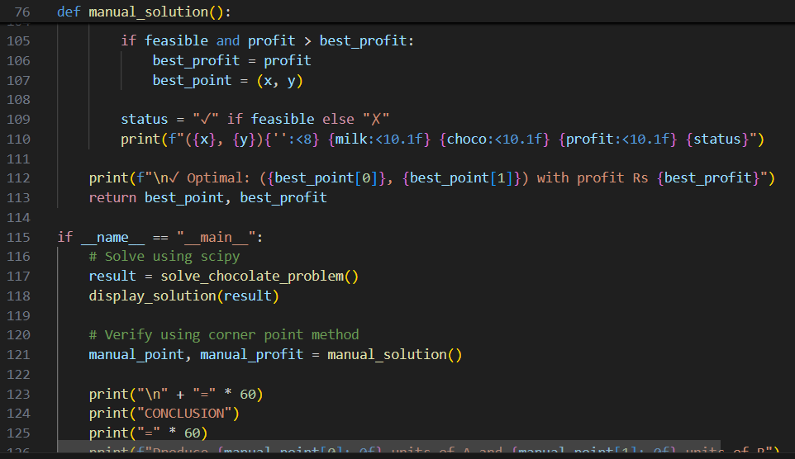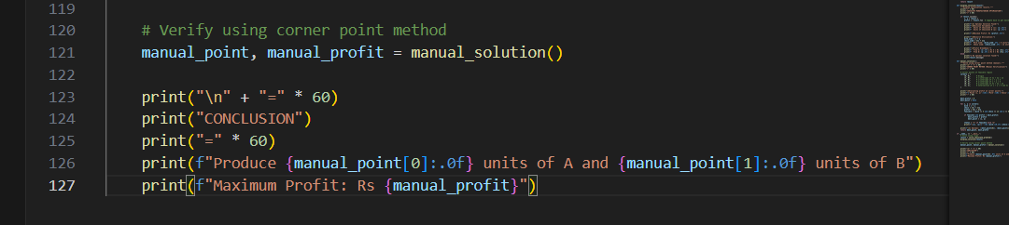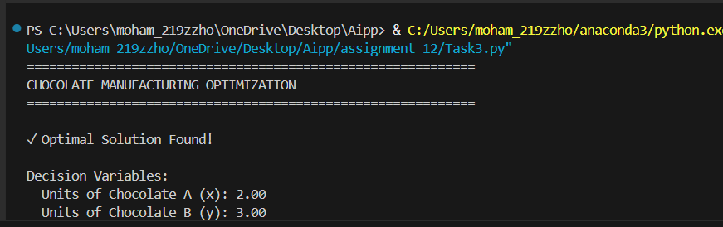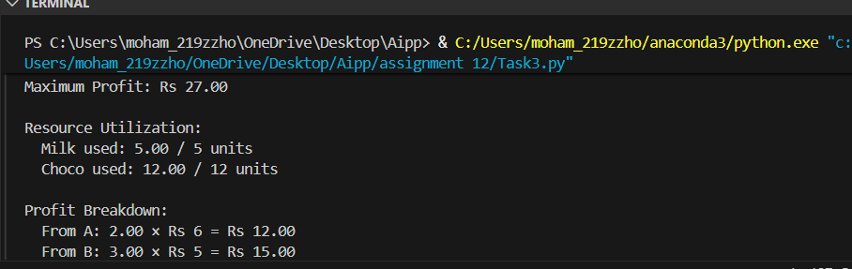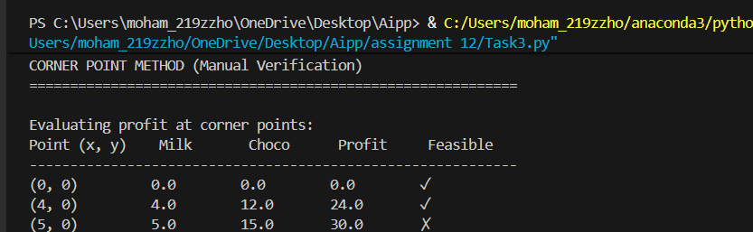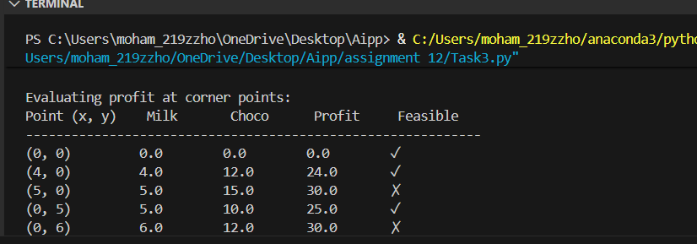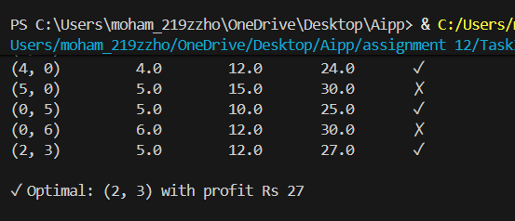  Task Description #4 – Gradient Descent Optimization  Task: Write python code to find value of x at which the function f(x)=2X³+4x+5 will be minimum 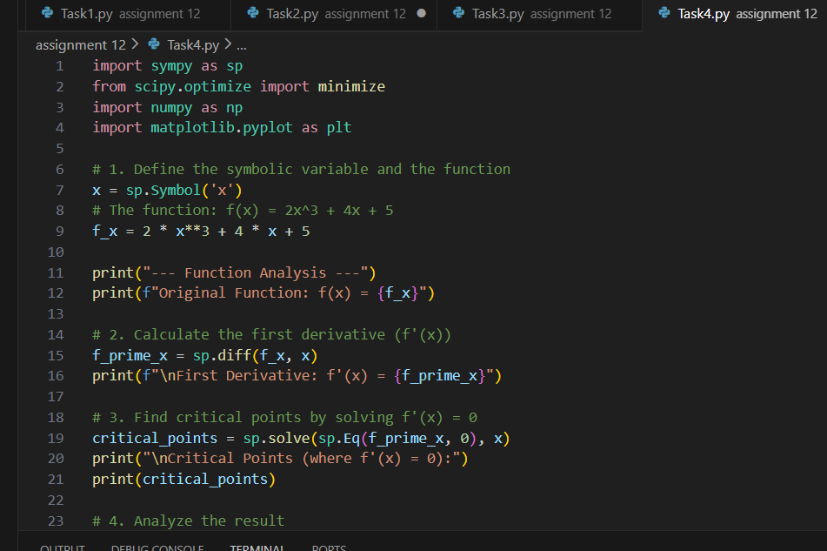 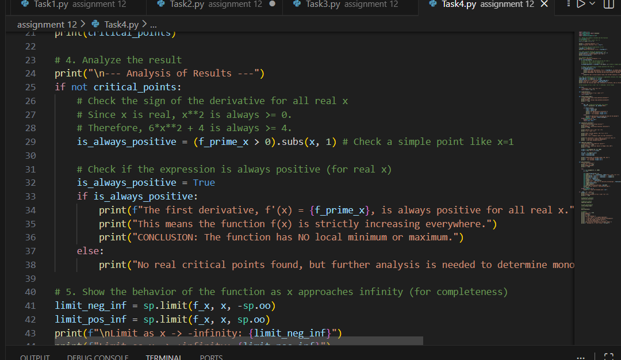 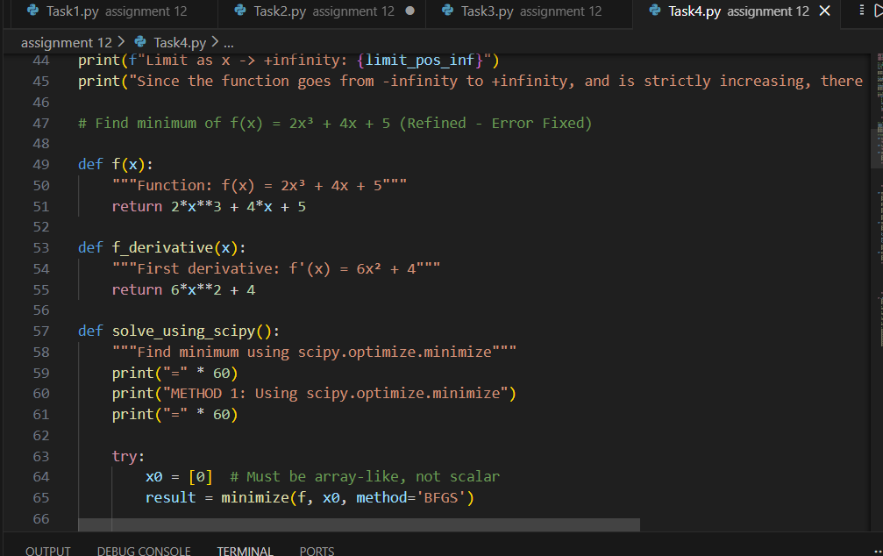 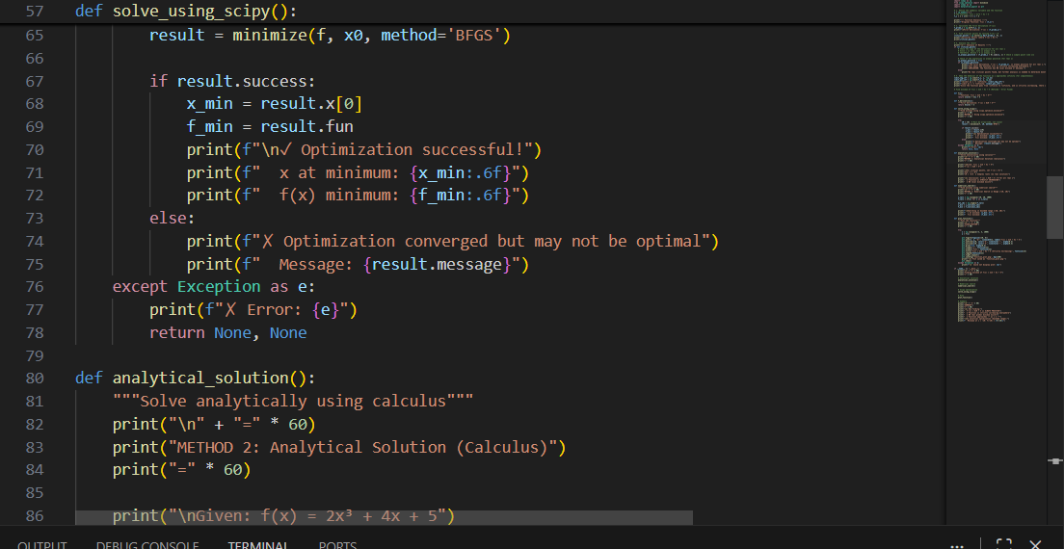 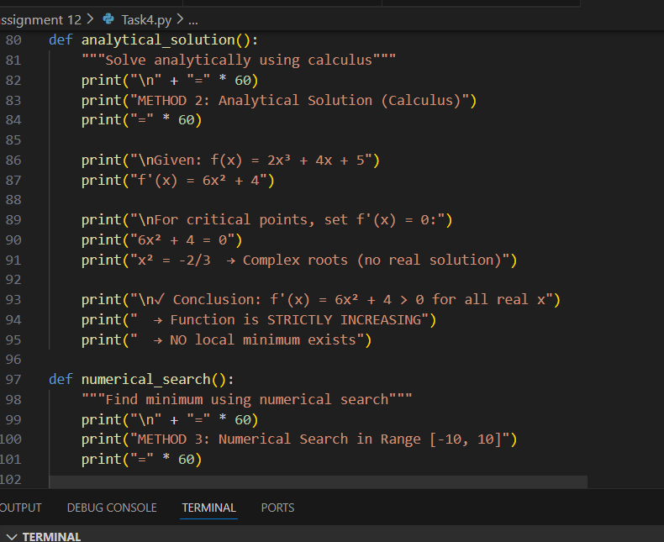 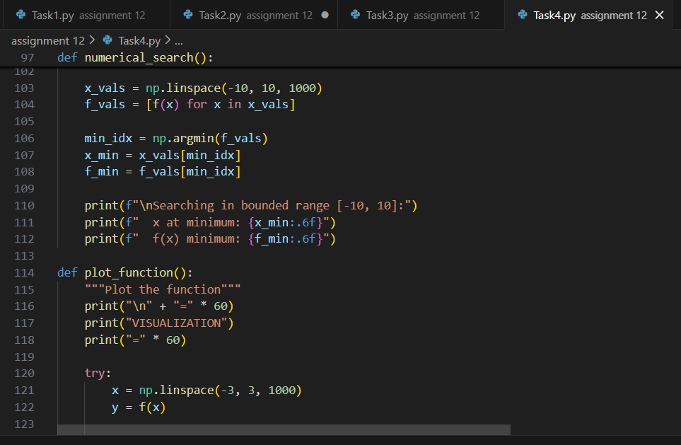 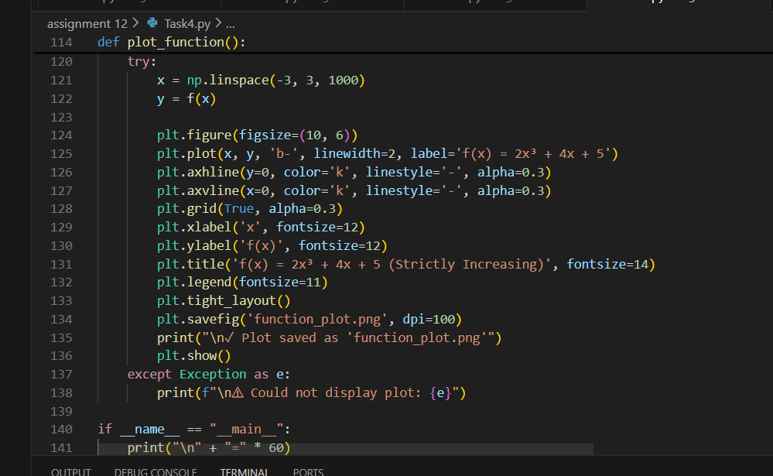 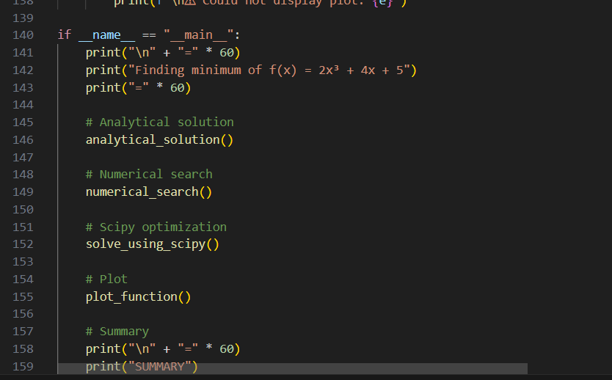 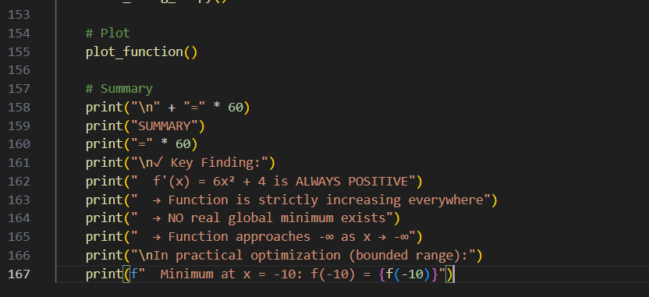 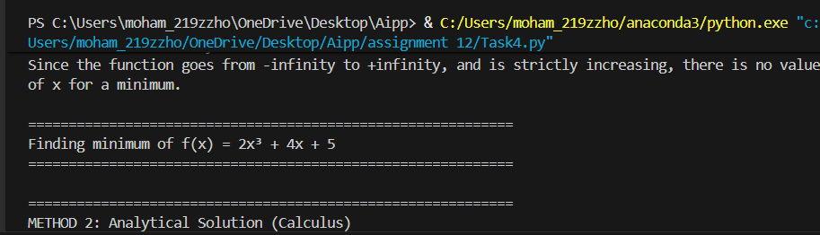 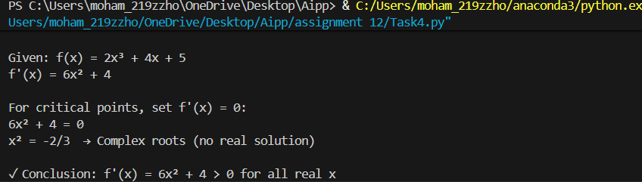 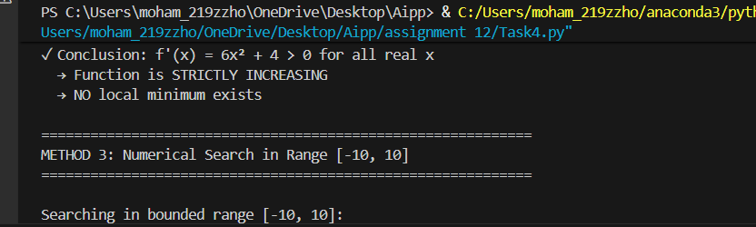 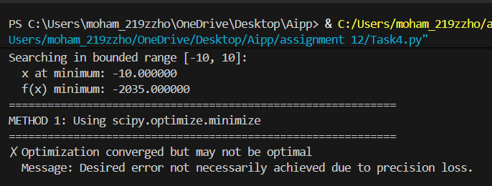 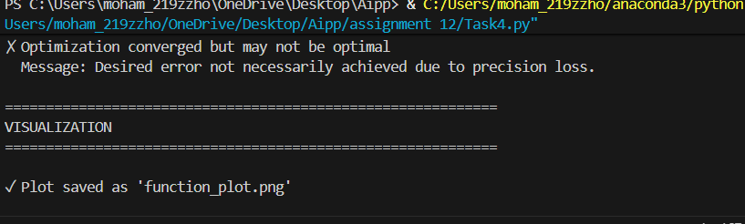  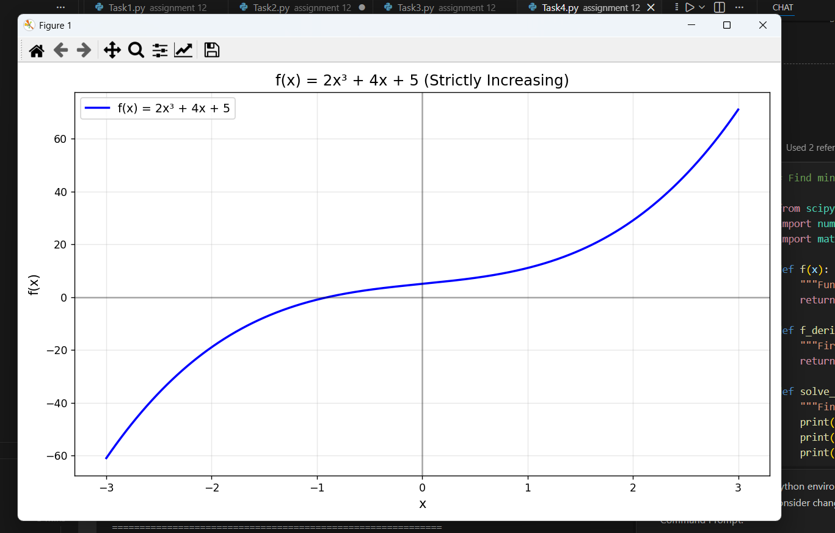 |  |  |  |  |  | Week5- Tuesday

